1. Polygons

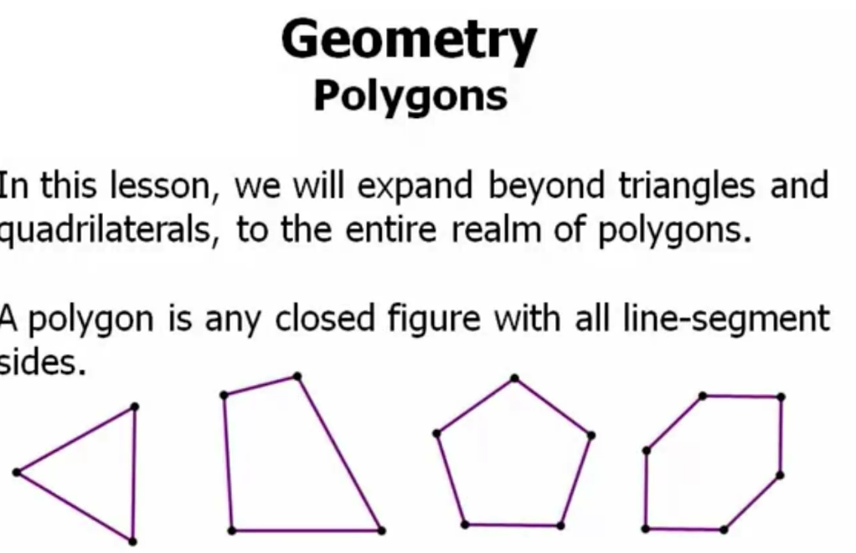

1. Exception

1. Need not to worry, polygon

1. Types

1. Diagonals in Polygons

1. Total Angles in Polygons

1. Pentagon – Can be separated into 3 triangles

1. Hexagon – 4 triangles

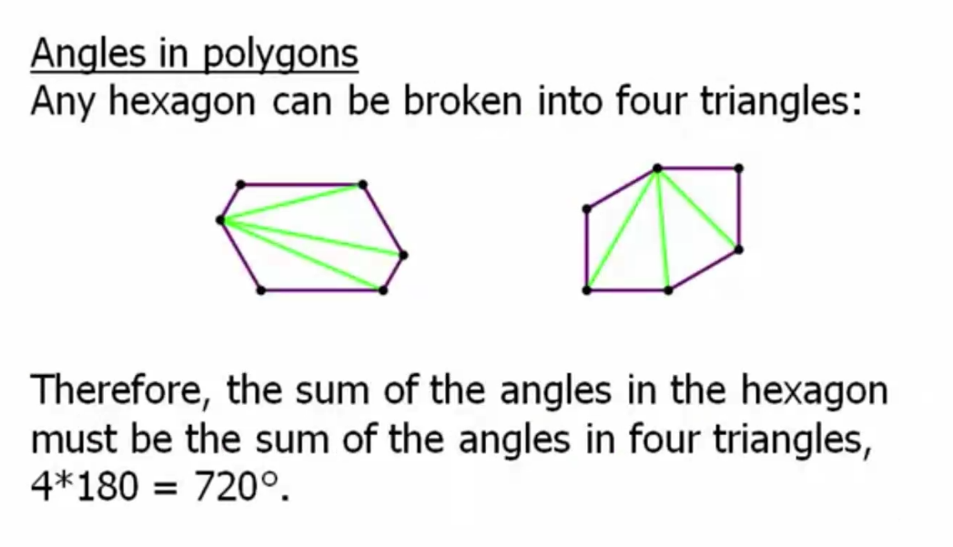

1. Separating the triangles with respect to the diagonals

1. To find angles in polygons

1. Summary

